Requirements gathering

ــــــــــــــــــــــــــــــــــــــــــــــــــــــــ

Gathering requirements is the main attraction of the Analysis Phase. The process of gathering requirements is usually more than simply asking the users what they need and writing their answers down. Depending on the complexity of the application, the process for gathering requirements has a clearly defined process of its own. This process consists of a group of repeatable processes that utilize certain techniques to capture, document, communicate, and manage requirements. This formal process, which will be developed in more detail, consists of four basic steps.

* **User and system requirements**
* **Functional and non-Functional requirements**
* **Constraints**
* **User requirements :**

All these aspects support the need to generate new technologies in order to develop automatic translation systems for converting this sign language into text or speech. First of all, it is necessary to define the scenarios of the system that we need to develop. In the case of our translation system, one scenario has been considered that correspond to personal services. In this scenario, one independent demo will be developed: this scenario will apply in a bank service. For these services, the next steps have been followed for the analysis and definition of requirements:

* General description of service:
* Convert sign language into text or speech.
* in detail:
* We need to translate the sign language of the deaf.
* Convert the sign language into a text understandable and readable without mistakes.
* Convert the sign language into audible and clear voice.
* Detects all signals that will occur.
* Sign language must be translated instantaneously and quickly detected.
* **system requirements :**

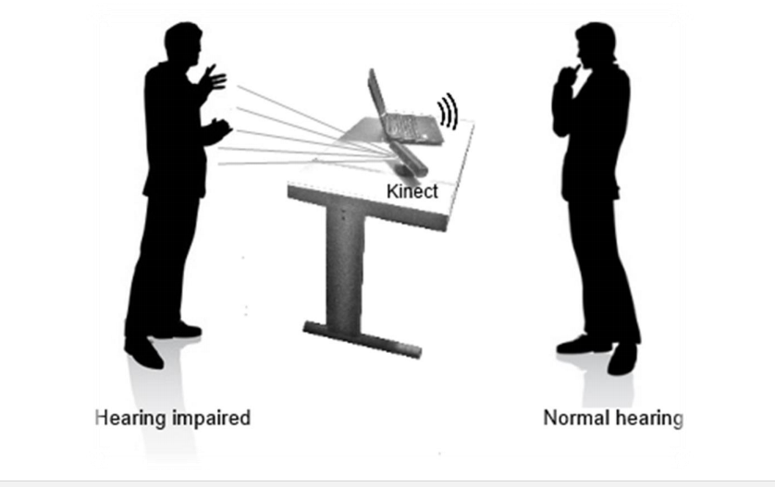

The idea is to facilitate the communication between hearing impaired and normal hearing people by building a translation system that uses Kinect. The system will play the role of human sign language interpreter that understands the sign language and translates it into text or speech for normal hearing people. We decided to make our system specified On Institutions Especially banks. Wherefore:

* Hearing impaired person should be able to perform sign that represent digit number.
* Hearing impaired person should be able to perform sign that represent alphabet letter.
* Hearing impaired person should be able to perform sign that represent word.
* Hearing impaired person should be able to perform sign that represent sentence.
* Normal hearing person should be able to see the translation of sign to text.

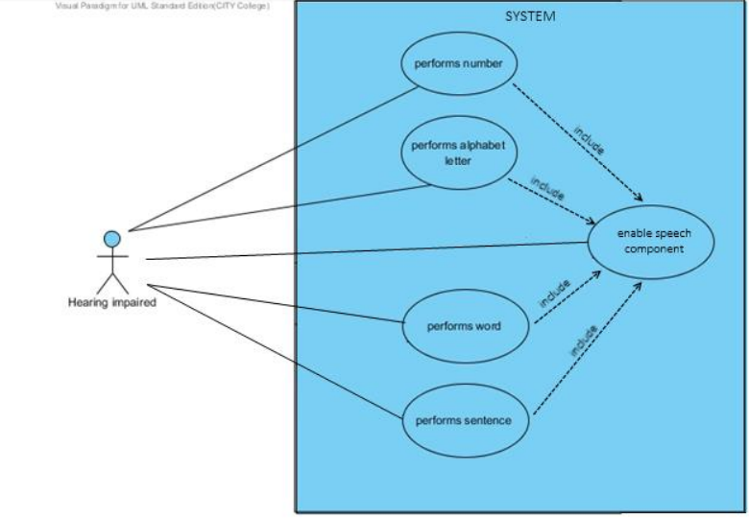

**Finally**, System requirements divided into:

* **Software**
* Image processing.
* Advanced computer vision techniques.
* Sign language modelling.
* Operating system.
* SDK for Kinect.
* C++ language.
* Open CV.
* **Hardware**
* PC or Laptop.
* Kinect device.
* Adapter.
* **Functional requirements:**

The functions that system should provide to its user are known as functional requirements. Although the fact that two people are involved, only one of them interacts directly with the system. This is the hearing impaired person that performs sings in front of Kinect and the system responds by translating them to text or speech. The other person can be considered as passive user since it does interacts directly with the system, but only listens or reads to recognized signs.

Requirements can be represented by describing the interaction that different actors (users, external systems) have with the system and where the:

* **System** is presented as black box.
* **Hearing impaired** is the person that performs the signs.
* **Normal hearing** is the passive user of the system.

**Finally,** the system will do :

* translate the sign language of the deaf.
* Convert the sign language into a text understandable and readable without mistakes.
* Convert the sign language into audible and clear voice.
* Detects all signals that will occur.
* Sign language translated instantaneously and quickly detected.
* **Non Functional requirements**

The conditions on which system should operate are specified as non-functional requirements and they are:

* **Real time** - the system should provide the recognition of signs and their translation to speech in an unnoticeable time for its users.
* **Accuracy** – signs should not be confused and the system should recognize appropriate sign.
* **Environment** – the system should provide real time recognition with high accuracy in low light conditions as well.
* **Usability** – the system should provide natural interaction to its users. The hearing impaired person needs to worry nothing else, just for performing signs.
* **Constraints**

Before proceeding to the phase of software development process selection, it is important to emphasize what system should not do in order to give clearer picture of software system to be developed.

Signs as presented in Literature Review section are composed from manual and non-manual (automatic such as eye blinking) features. In general, manual features of sing involve hands while non-manual features involve facial expressions, body postures and head movements. The project will be limited to recognition of manual signs because of the limited time of the project.

The system is thought to be functional only in in-door environments, since the infrared lights that Kinect employs as part of depth measuring are destructed by sun-lights and use of it in outdoor environments is unreliable.